**Steps to install Hadoop:**

1. Make sure java is installed.

**java -version**

If java is not installed, then type in the following commands:

**sudo apt-get install update**

**sudo apt-get update**

**sudo apt-get install default-jdk**

Make sure now java is installed.

**java -version**

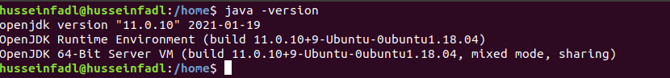

1. Install ssh server

**sudo apt-get install ssh-server**

Generate public/private RSA key pair.

**ssh-keygen -t rsa -P “”**

When prompted for the file name to save the key, press Enter (leave it blank).

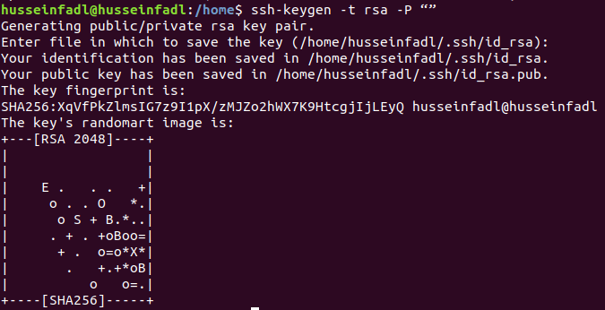Type the following commands:

**cat $HOME/.ssh/id_rsa.pub >> $HOME/.ssh/authorized_keys**

**ssh localhost**

**exit**

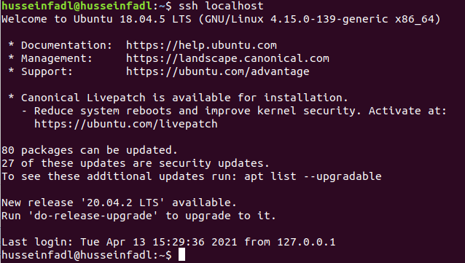



1. Install Hadoop by navigating to the following link and downloading the tar.gz file for Hadoop version 3.3.0 (or a later version if you wish). (478 MB)

<https://hadoop.apache.org/release/3.3.0.html>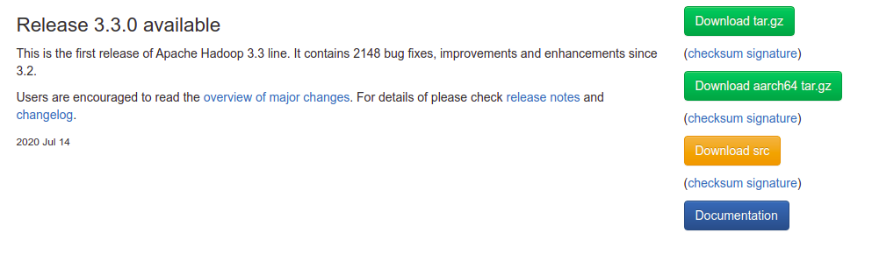

1. Once downloaded, open the terminal and cd to the directory where it is downloaded (assume the desktop for example) and extract it as follows:

**cd Desktop**

**sudo tar -xvzf hadoop-3.3.0.tar.gz**

You can now check that there is an extracted file named hadoop-3.3.0 by typing the command “ls” or by visually inspecting the files.

1. Now, we move the extracted file to the location /usr/local/hadoop

**sudo mv hadoop-3.3.0 /usr/local/hadoop**

1. Let’s configure the hadoop system.

Type the following command:

**sudo gedit ~/.bashrc**

At the end of the file, add the following lines: (Note: Replace the java version with the version number you already have. You can navigate to the directory /usr/lib/jvm and check the file name java-xx-openjdk-amd64)

export JAVA_HOME=/usr/lib/jvm/java-**11**-openjdk-amd64

export HADOOP_HOME=/usr/local/hadoop

export PATH=$PATH:$HADOOP_HOME/bin

export PATH=$PATH:$HADOOP_HOME/sbin

export HADOOP_MAPRED_HOME=$HADOOP_HOME

export HADOOP_COMMON_HOME=$HADOOP_HOME

export HADOOP_HDFS_HOME=$HADOOP_HOME

export YARN_HOME=$HADOOP_HOME

export HADOOP_COMMON_LIB_NATIVE_DIR=$HADOOP_HOME/native

export HADOOP_OPTS="-Djava.library.path=$HADOOP_HOME/native"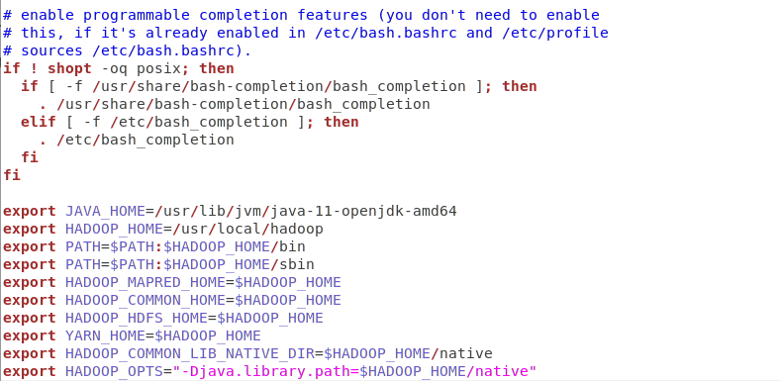

1. Save the file and close it.
2. Now from the terminal, type the following command:

**source ~/.bashrc**

1. We start configuring Hadoop by opening **hadoop-env.sh** as follows:

**sudo gedit /usr/local/hadoop/etc/hadoop/hadoop-env.sh**

Search for the line starting with **export JAVA_HOME=** and replace it with the following line.

**export JAVA_HOME=/usr/lib/jvm/java-11-openjdk-amd64**

Save the file by clicking on “Save” or (Ctrl+S)

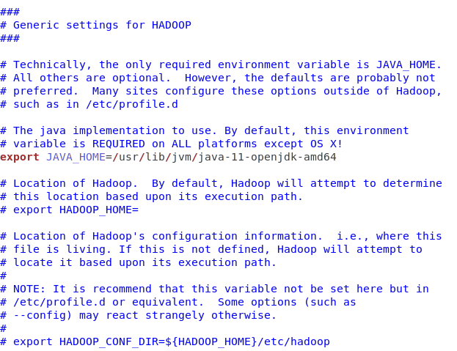

1. Open **core-site.xml** as follows:

**sudo gedit /usr/local/hadoop/etc/hadoop/core-site.xml**

Add the following lines between the tags <configuration> and </configuration> and save it (Ctrl+S).

**<property>  
 <name>fs.default.name</name>  
 <value>hdfs://localhost:9000</value>  
</property>**

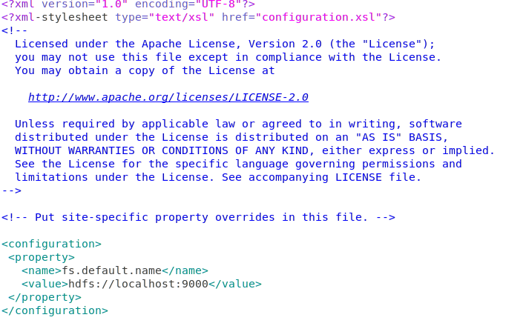

1. Open **hdfs-site.xml** as follows:

**sudo gedit /usr/local/hadoop/etc/hadoop/hdfs-site.xml**

Add the following lines between the tags <configuration> and </configuration> and save it (Ctrl+S).

**<property>**

**<name>dfs.replication</name>**

**<value>1</value>**

**</property>**

**<property>**

**<name>dfs.namenode.name.dir</name>**

**<value>file:/usr/local/hadoop_space/hdfs/namenode</value>**

**</property>**

**<property>**

**<name>dfs.datanode.data.dir</name>**

**<value>file:/usr/local/hadoop_space/hdfs/datanode</value>**

**</property>**

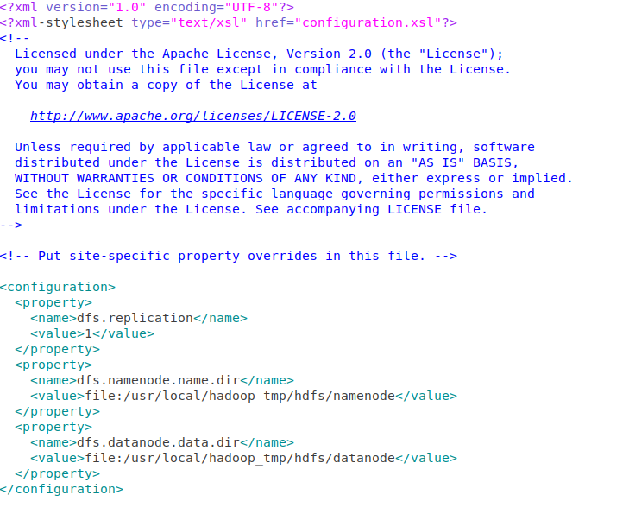

1. Open **yarn-site.xml** as follows:

**sudo gedit /usr/local/hadoop/etc/hadoop/yarn-site.xml**

Add the following lines between the tags <configuration> and </configuration> and save it (Ctrl+S)

**<property>**

**<name>yarn.nodemanager.aux-services</name>**

**<value>mapreduce_shuffle</value>**

**</property>**

**<property>**

**<name>yarn.nodemanager.aux-services.mapreduce.shuffle.class</name>**

**<value>org.apache.hadoop.mapred.ShuffleHandler</value>**

**</property>**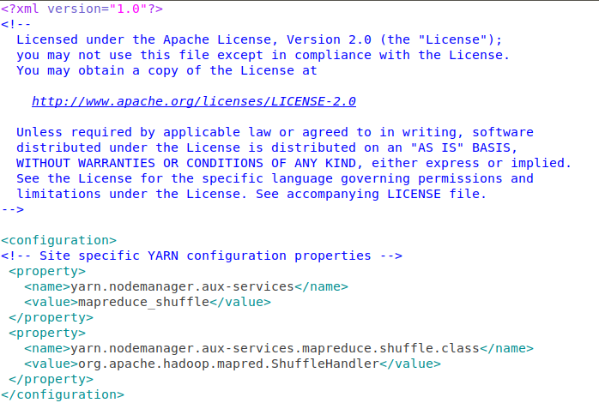

1. Open **mapred-site.xml** as follows:

**sudo gedit /usr/local/hadoop/etc/hadoop/mapred-site.xml**

Add the following lines between the tags <configuration> and </configuration> and save it (Ctrl+S)

**<property>**

**<name>mapreduce.framework.name</name>**

**<value>yarn</value>**

**</property>**

**<property>**

**<name>yarn.app.mapreduce.am.env</name>**

**<value>HADOOP_MAPRED_HOME=${HADOOP_HOME}</value>**

**</property>**

**<property>**

**<name>mapreduce.map.env</name>**

**<value>HADOOP_MAPRED_HOME=${HADOOP_HOME}</value>**

**</property>**

**<property>**

**<name>mapreduce.reduce.env</name>**

**<value>HADOOP_MAPRED_HOME=${HADOOP_HOME}</value>**

**</property>**

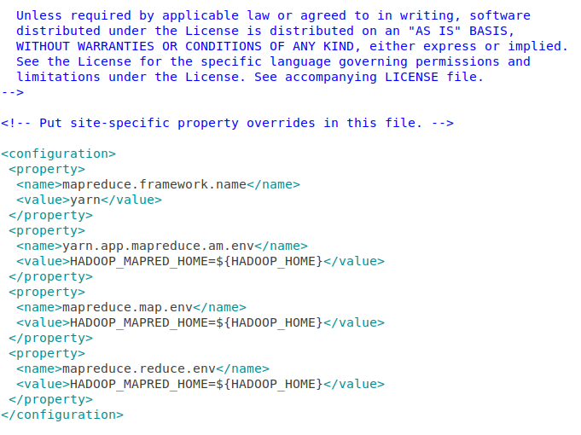

1. Now, run the following commands on the terminal to create a directory for hadoop space, name node and data node.

* **sudo mkdir -p /usr/local/hadoop_space**
* **sudo mkdir -p /usr/local/hadoop_space/hdfs/namenode**
* **sudo mkdir -p /usr/local/hadoop_space/hdfs/datanode**

Now we have successfully installed Hadoop.

1. Format the namenode as follows:

**hdfs namenode -format**

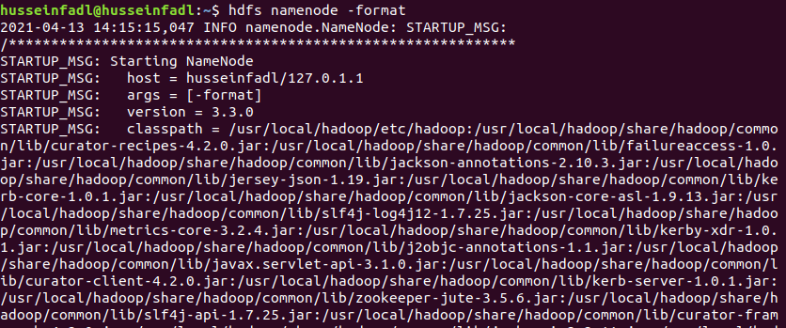

This step should end by shutting down the namenode as follows:

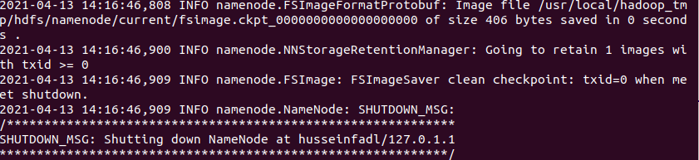

1. Before starting the Hadoop Distributed File System (hdfs), we need to make sure that the rcmd type is “ssh” not “rsh” when we type the following command

* **pdsh -q -w localhost**

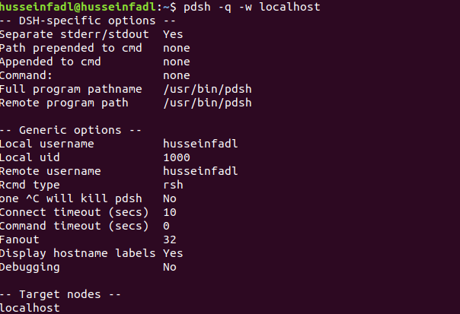

1. If the rcmd type is “rsh” as in the above figure, type the following commands:

**export PDSH_RCMD_TYPE=ssh**

**cat $HOME/.ssh/id_rsa.pub >> $HOME/.ssh/authorized_keys  
chmod 0600 ~/.ssh/authorized_keys**

Run Step 16 again to check that the rcmd type is now ssh.

If not, skip that step.

1. Start the HDFS System using the command.

**start-dfs.sh**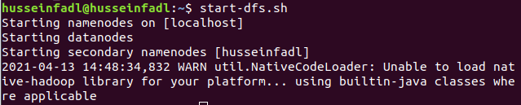

1. Start the YARN using the command

**start-yarn.sh**



1. Type the following command. You should see an output similar to the one in the following figure.

**jps**



Make sure these nodes are listed: (ResourceManager, NameNode, NodeManager, SecondaryNameNode, Jps and DataNode).

1. Go to localhost:9870 from the browser. You should expect the following

